Name: Date: wor words

When the letter w comes before the letters or, it changes the sound that these letters represent, like in the words below.

Remember: Say the word aloud, then say each letter aloud as you write it e.g. 'word, w ... o ... r ... d'
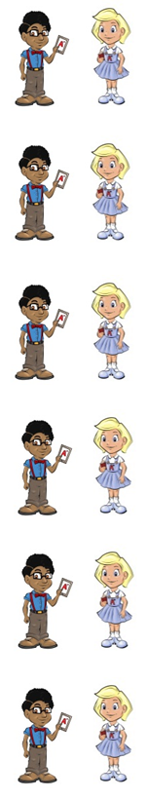
Each word is made up of letters.

How much work have you done?

A worm lives in soil.

The world is huge.

Is it worth getting into trouble?

Neil is the worst behaved boy in his class.

The word were is a naughty red word that belongs to Nina and Neil because it does not use the letters wor. The words sword and worn are naughty red words because they use the letters wor differently to most words.

Were you in school on Monday?

Have you worn your new shirt?

A sword needs to be sharp.

Now test yourself without looking at the words and check for yourself if you got them all right. Practice writing any words that you made mistakes on again.

© www.SaveTeachersSundays.com 2013
Name: Date: wor words

When the letter w comes before the letters or, it changes the sound that these letters represent, like in the words below.

Remember: Say the word aloud, then say each letter aloud as you write it e.g. 'word, w ... o ... r ... d'

Try to spell each word without looking at it.

Each is made up of letters.

How much have you done?

A lives in soil.

The is huge.

Is it getting in trouble?

Neil is the behaved boy in his class.

you in school on Monday?

Have you your new shirt?

A needs to be sharp.

Now check for yourself if you got them all right. Practice writing any words that you made mistakes on again.

© www.SaveTeachersSundays.com 2013

